CS 305 Project One Template

Document Revision History

Version | Date | Author | Comments
1.0 | 3/19/2026 | Dominic Rodriguez

Client



Instructions
Submit this completed vulnerability assessment report. Replace the bracketed text with the relevant information. In this report, identify your security vulnerability findings and recommend the next steps to remedy the issues you have found.

- Respond to the five steps outlined below and include your findings.
- Respond using your own words. You may also include images or supporting materials. If you include them, make certain to insert them in the relevant locations in the document.
- Refer to the Project One Guidelines and Rubric for more detailed instructions about each section of the template.

Developer
Dominic Rodriguez

1. Interpreting Client Needs
Determine your client’s needs and potential threats and attacks associated with the company’s application and software security requirements. Consider the following questions regarding how companies protect against external threats based on the scenario information:

- What is the value of secure communications to the company?
- Are there any international transactions that the company produces?
- Are there governmental restrictions on secure communications to consider?
- What external threats might be present now and in the immediate future?
- What modernization requirements must be considered, such as the role of open-source libraries and evolving web application technologies?

This company, Artemis Financial, aims to provide financial plans to people who are interested in investing in a retirement account and opening a savings account. With this plan, Artemis Financial handles a lot of private information from clients requiring secure communication between the company and its clients. There could be international transactions for this company as it is not specifically listed as not handling foreign transactions. Even if the company does not deal with international transactions currently, there is the possibility of expanding into foreign transactions in the future. There are governmental restrictions in place to ensure financial stability, preventing illegal activity, as well as protecting their clients. This can be through protecting client privacy, preventing fraud, and maintaining records for regulatory oversight. An external threat that is present now and, in the future, could be a leak of client information including banking and personal information. A modern requirement needed would be firewalls and restrictions to not allow anyone outside of the bank to access client information without explicit permission from the client themselves. There would also need to be constant checks to ensure there are no breaches and no possibilities of breaches in the future.

2. Areas of Security
Refer to the vulnerability assessment process flow diagram. Identify which areas of security apply to Artemis Financial’s software application. Justify your reasoning for why each area is relevant to the software application.

- Input validation
  - Preventing attacks from unknown users
- Cryptography
  - Prevents user information being accessed from non-bank personnel
- Client/server
  - Only allowing access to the servers by clients and employees of the bank
- Code quality
  - Prevents hackers from easily accessing information
- Encapsulation
  - Only allowing the public to see public interface and restricting access to internal code

3. Manual Review
Continue working through the vulnerability assessment process flow diagram. Identify all vulnerabilities in the code base by manually inspecting the code.

- CWE-20
  - Improper input validation
- CWE-502
  - Deserialization of untrusted data
- CWE-94
  - Improper control of generation of code
- CWE-459
  - Incomplete cleanup

4. Static Testing
Run a dependency check on Artemis Financial’s software application to identify all security vulnerabilities in the code. Record the output from the dependency-check report. Include the following items:

- The names or vulnerability codes of the known vulnerabilities
- A brief description and recommended solutions provided by the dependency-check report
- Any attribution that documents how this vulnerability has been identified or documented previously

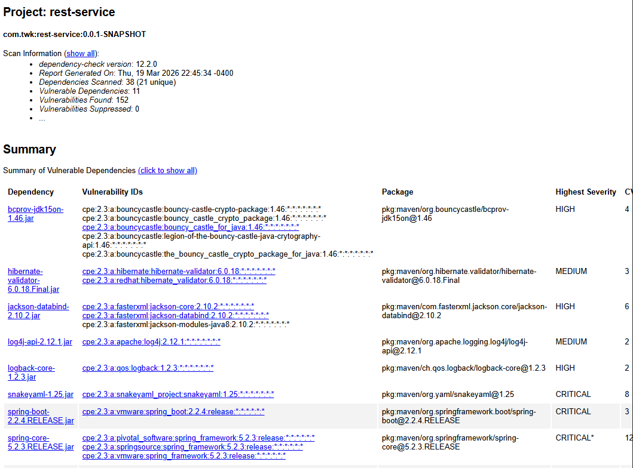

- CVE-2023-33202
  - Bouncy Castle for Java before 1.73 contains a potential denial of service issue
- CVE-2023-1932
  - Interpolate user-supplied input in a constraint violation message with expression language
- CVE-2020-25649
  - Entity expansion has not been secured properly. Allows vulnerability to XML external entity attacks
- CVE-2025-68161
  - Does not perform TLS hostname verification of peer certificate
- CVE-2023-6378
  - Serialization vulnerability in log back receiver component part of log back version 1.4.11
- CVE-2022-1471
  - Does not restrict types which can be instantiated during deserialization
- CVE-2023-20873
  - Deployed to Cloud Foundry could be susceptible to a security bypass
- CVE-2022-22965
  - May be vulnerable to remote code execution

5. Mitigation Plan
Interpret the results from the manual review and static testing report. Then identify the steps to mitigate the identified security vulnerabilities for Artemis Financial’s software application.

To mitigate the security vulnerabilities for Artemis Financial’s software application, there needs to be a set plan based on the highest severity while filtering any false positives to ensure all resources are being used to mitigate rather than wasting resources. There also needs to be detailed steps to fix any vulnerabilities and security issues, so everyone is working on the same vulnerability based on severity. There should also be a constant monitoring for future issues that may arise.

